**The various data size result is given below:**

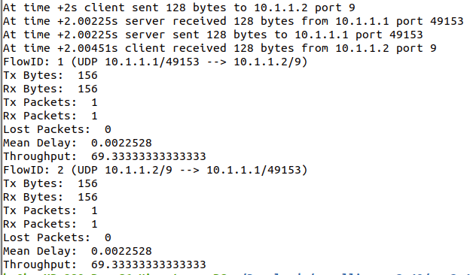

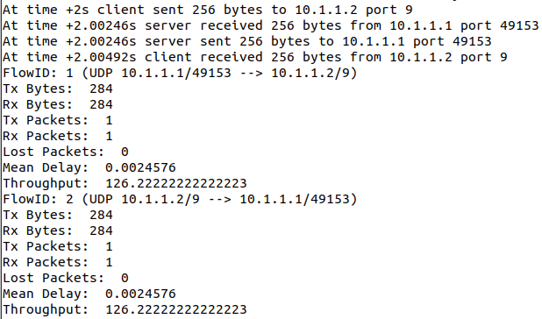

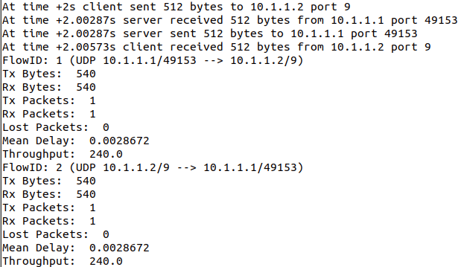

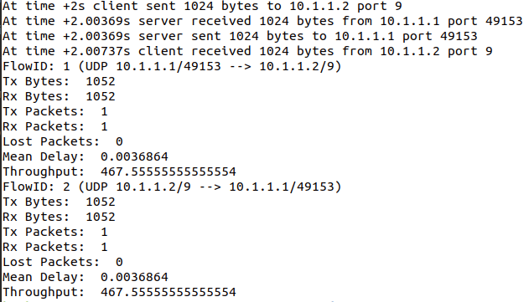

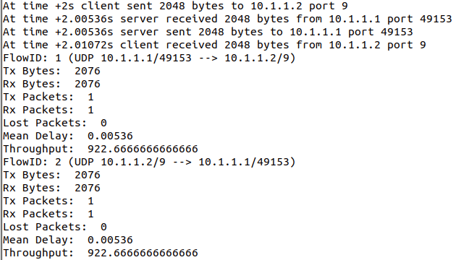

**Throughput vs data size graph:**

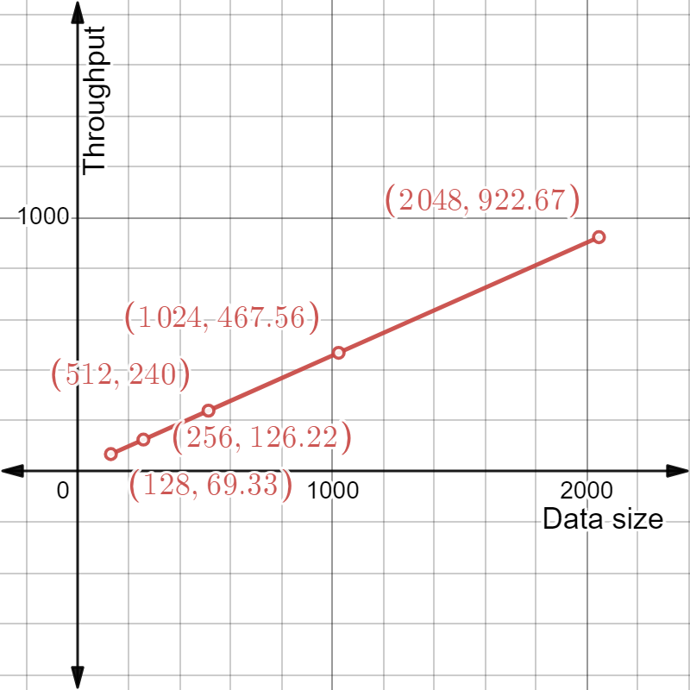

Here we can see that, the slope of the line is same all over it. Therefore, it has a linear relation.

From the graph, we can see that throughput is proportional to data size. The throughput increases gradually in a constant rate as the data size increases.